Ex.No: 16

Date:

**HIGH LEVEL LANGUAGE EXTENSION WITH CURSORS**

**Program 1**

Write a Cursor program using MySQL to retrieve the email-ids(build an email list) of employees from employees table.

**SOLUTION :**

create table employees(id integer, Name varchar(100), email varchar(100)); insert into employees(id, Name, email) values(1, "Harry Potter", "pharry@warnerbros.com");

insert into employees(id, Name, email) values(2, "Clark Kent", "kclark@dccomics.com");

insert into employees(id, Name, email) values(3, "Tony Stark", "stony@marvel.com");

DELIMITER //

CREATE PROCEDURE build_email_list (INOUT email_listvarchar(4000))

BEGIN

DECLARE v_finished INTEGER DEFAULT 0;

DECLARE v_emailvarchar(100) DEFAULT "";

-- declare cursor for employee email

DEClAREemail_cursor CURSOR FOR

SELECT email FROM employees;

-- declare NOT FOUND handler

DECLARE CONTINUE HANDLER FOR

NOT FOUND SET v_finished = 1;

OPEN email_cursor;

get_email: LOOP

FETCH email_cursor INTO v_email;

IF v_finished = 1 THEN

LEAVE get_email;

END IF;

-- build email list

SET email_list = CONCAT(v_email,";",email_list);

END LOOP get_email;

CLOSE email_cursor;

END //

DELIMITER ;

-- Calling the procedure and getting the email list

SET @email_list = "";

CALL build_email_list(@email_list);

SELECT @email_list;

**OUTPUT:**

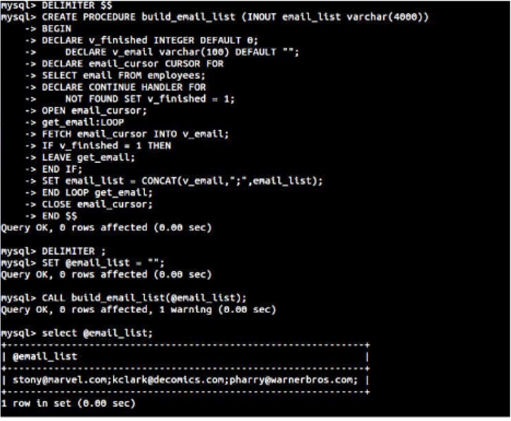

**RESULT:**

stony@marvel.com;kclark@dccomics.com;pharry@warnerbros.com;